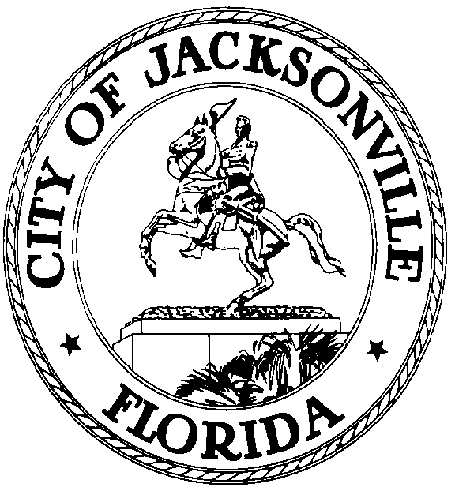

GARRETT L. DENNIS
Council Member District 9
E-Mail: GarrettD@coj.net

OFFICE OF THE CITY COUNCIL
117 West Duval Street City Hall, Suite 425
Jacksonville, Florida 32202
Office (904) 255-5209
Fax (904) 255-5230
.

MEDIA RELEASE

FOR IMMEDIATE RELEASE – June 4, 2020
Contact: Garrett Dennis (904) 887-1870

COUNCIL MEMBER GARRETT DENNIS INTRODUCES LEGISLATION THAT ADDRESSES CITIZENS’ CONCERNS REGARDING A WIDE RANGE OF ISSUES

JACKSONVILLE, Fla. – In an effort to take meaningful legislative action, Council Member Garrett Dennis has introduced the following legislation:

- 2020-0325 A resolution urging Sheriff Williams to work cooperatively with the State Attorney’s Office, along with public input, to refine and improve the current policy regarding the release of body camera.
- 2020-0326 A resolution supporting the passage of a policy designating City Hall as a “Hit Free Zone,” to include training of employees for an appropriate response.
- 2020-0320 An ordinance relating to the Council Rules to allow for public comment at the beginning of City Council meetings as well as the end.
- 2020-0311 An amendment to the Jacksonville Small Emerging Business Program, mandating a 20% goal on all contracts for small and emerging businesses, which could potentially secure $60 million in contracting opportunities annually.

